
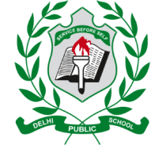
DELHI PUBLIC SCHOOL, HAPUR
Session- 2026-27
Hindi Rhyme Recitation Competition Result
Class: Balvatika- 1/2/3
Name | Class | Position | Photo
Hurain | Balvatika-1 | 1st | 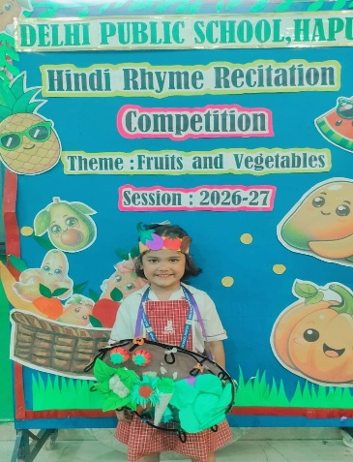
Shashwat Mani Pandey | Balvatika-1 | 2nd | 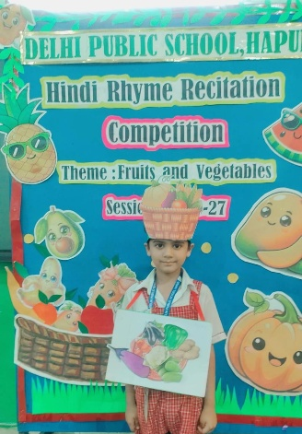
Jasman Singh | Balvatika-1 | 3rd | 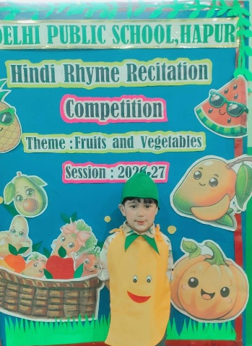
Daivik Tomar | Balvatika-2A | 1st | 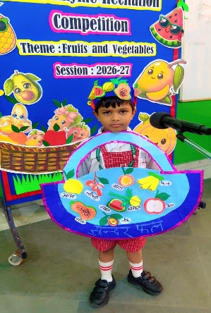
Inaya Asad | Balvatika-2A | 1st | 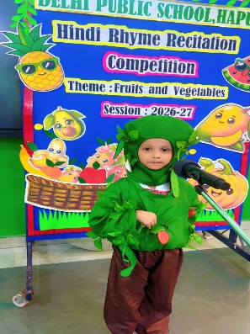
Shivansh | Balvatika-2A | 2nd | 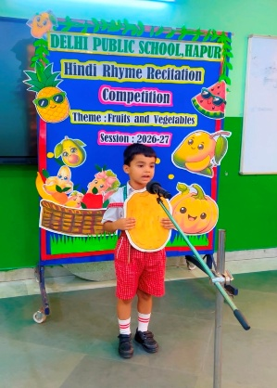
Kunwar Ahaan Ali | Balvatika-2A | 3rd | 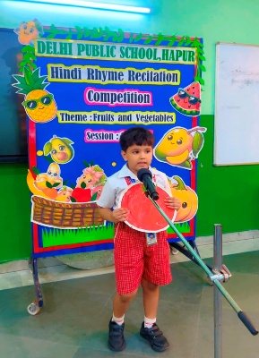
Zaira Hassan Khan | Balvatika-2A | 3rd | 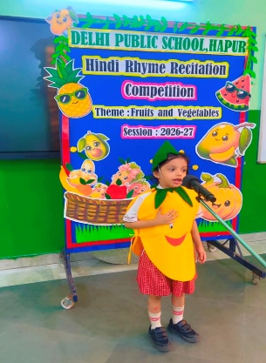
Aadvik Dixit | Balvatika-2A | Consolation | 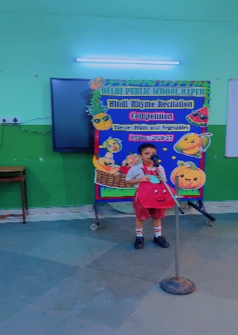
Izhaan Rana | Balvatika-2A | Consolation | 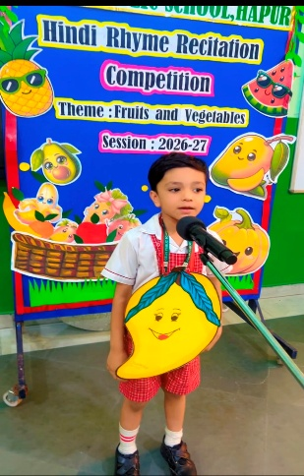
Bhoumik | Balvatika-2B | 1st | 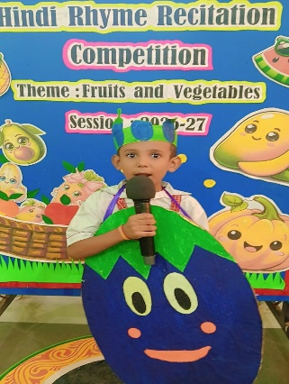
Virat Kishore Tyagi | Balvatika-2B | 1st | 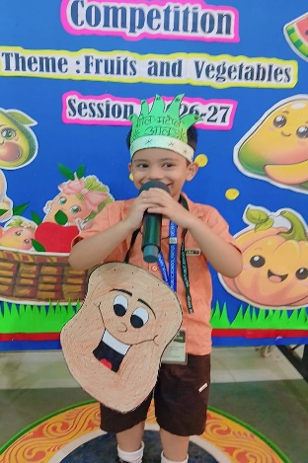
Arjun | Balvatika-2B | 2nd | 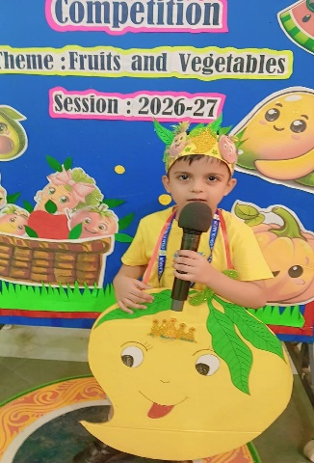
Moumita Narrayan | Balvatika-2B | 2nd | 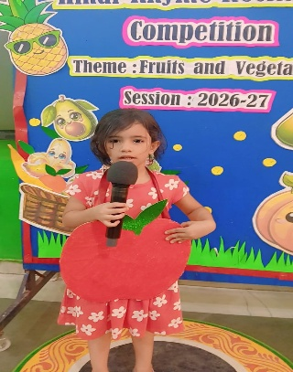
Priyankar Gautam | Balvatika-2B | 3rd | 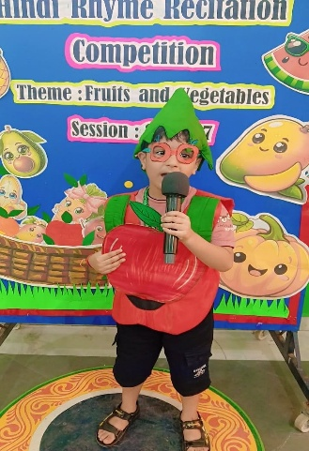
Adishri | Balvatika-2B | 3rd | 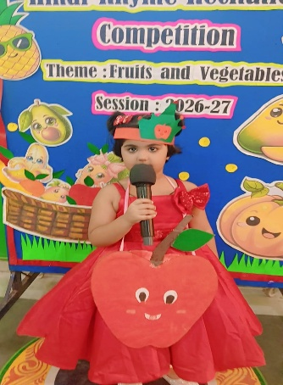
Abubakar | Balvatika-2B | 3rd | 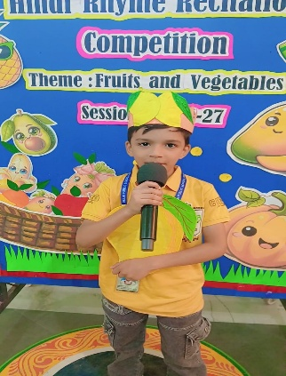
Daeshi | Balvatika-2B | Consolation | 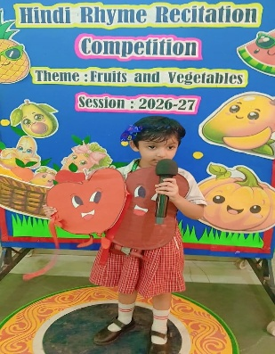
Manushree Garg | Balvatika-2B | Consolation | 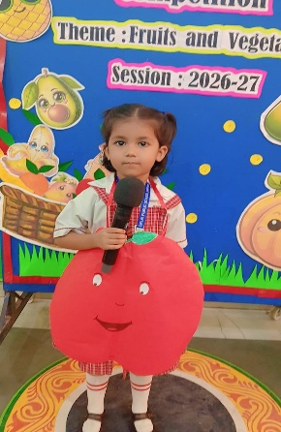
Siddharth Verma | Balvatika-2B | Consolation | 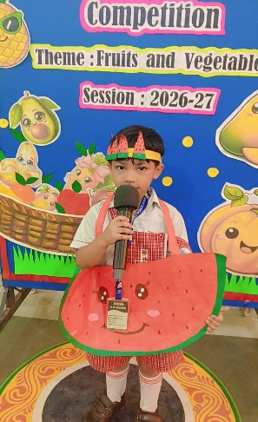
Prithvi Chaudhary | Balvatika-2B | Consolation | 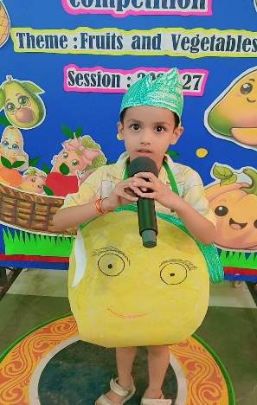
Lavanya | Balvatika-3A | 1st | 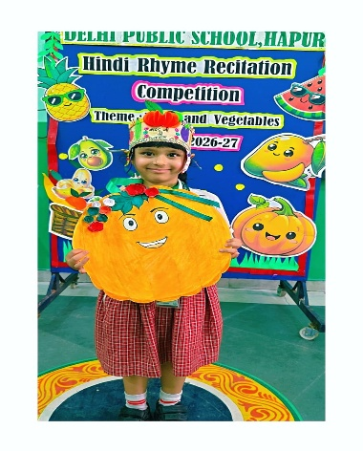
Anvi Singhal | Balvatika-3A | 1st | 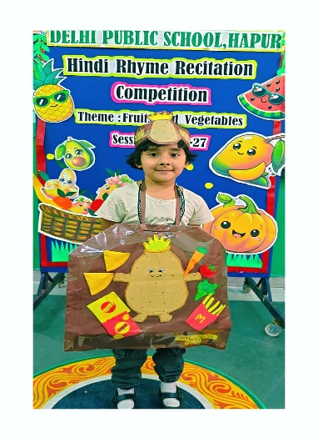
Atharv Sharma | Balvatika-3A | 2nd | 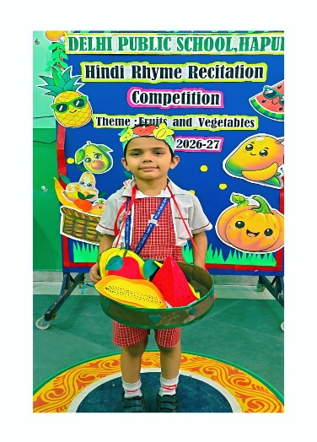
Rahil Khan | Balvatika-3A | 2nd | 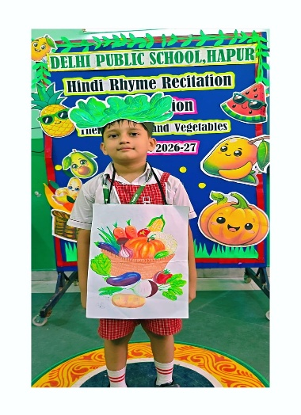
Rudraksh Tyagi | Balvatika-3A | 3rd | 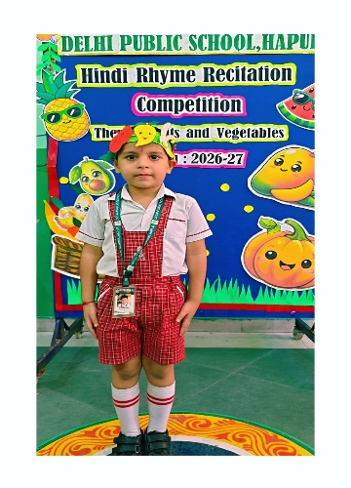
Lavisha Goel | Balvatika-3A | 3rd | 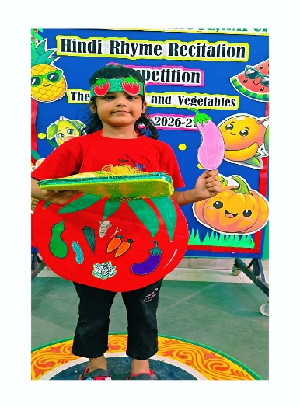
Anvay Tyagi | Balvatika-3B | 1st | 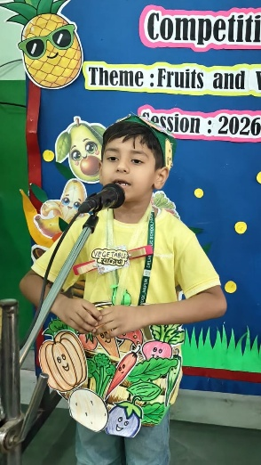
Ananya | Balvatika-3B | 2nd | 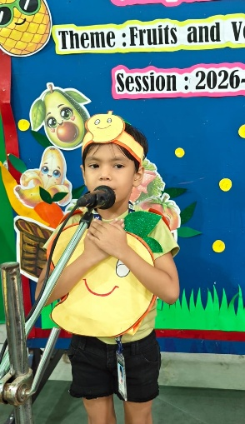
Kaavyansh Aaryan | Balvatika-3B | 2nd | 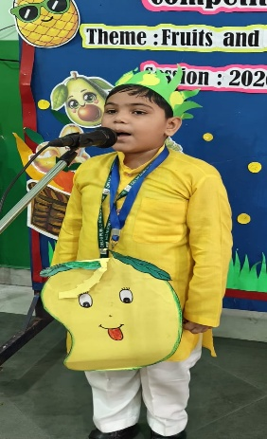
Hiba | Balvatika-3B | 3rd | 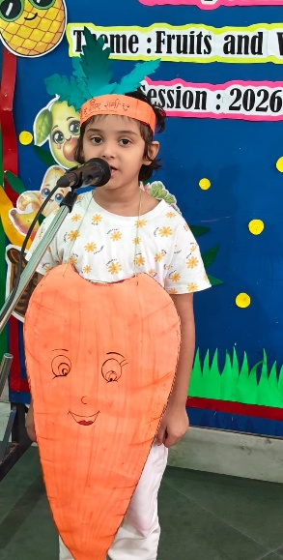
Bhumanyu Chaudhary | Balvatika-3B | Consolation | 